# Comparative Study of SQL and NoSQL Databases with Features of MongoDB

## Introduction

Databases are fundamental components in the world of data storage and management. SQL and NoSQL databases are two broad classifications that cater to different needs of modern applications. SQL databases are traditionally used for structured data, while NoSQL databases handle unstructured or semi-structured data more flexibly.

## SQL Databases

SQL databases, also known as relational databases, use structured query language (SQL) to manage and manipulate structured data. Examples include MySQL, PostgreSQL, Oracle, and Microsoft SQL Server. These databases follow ACID (Atomicity, Consistency, Isolation, Durability) properties to ensure reliable transactions.

**Common SQL Databases:**

* MySQL
* PostgreSQL
* Microsoft SQL Server
* Oracle Database

**Key Features of SQL Databases:**

* **Structured Schema:** Predefined schema that enforces data integrity.
* **ACID Compliance:** Ensures reliable transactions through Atomicity, Consistency, Isolation, and Durability.
* **Complex Queries:** SQL enables complex joins and aggregations across multiple tables.
* **Normalization:** Data is normalized to eliminate redundancy.
* **Consistency:** Ideal for systems that require strict consistency (e.g., banking applications).

## NoSQL Databases

NoSQL databases are non-relational and are designed to handle unstructured, semi-structured, or distributed data. They are suitable for big data and real-time applications. Types of NoSQL databases include document stores, key-value stores, wide-column stores, and graph databases. Examples are MongoDB, Cassandra, Couchbase, and Redis.

**Types of NoSQL Databases:**

* **Document-based (e.g., MongoDB)**
* **Key-Value stores (e.g., Redis)**
* **Column-family stores (e.g., Cassandra)**
* **Graph databases (e.g., Neo4j)**

**Key Features of NoSQL Databases:**

* **Flexible Schema:** Suitable for rapidly changing data models.
* **Scalability:** Easily scalable horizontally by distributing data across servers.
* **High Performance:** Ideal for applications requiring fast read/write operations.
* **Availability:** Focus on availability and partition tolerance (as per the CAP theorem).
* **Semi-Structured Data Handling:** Handles JSON, XML, etc.

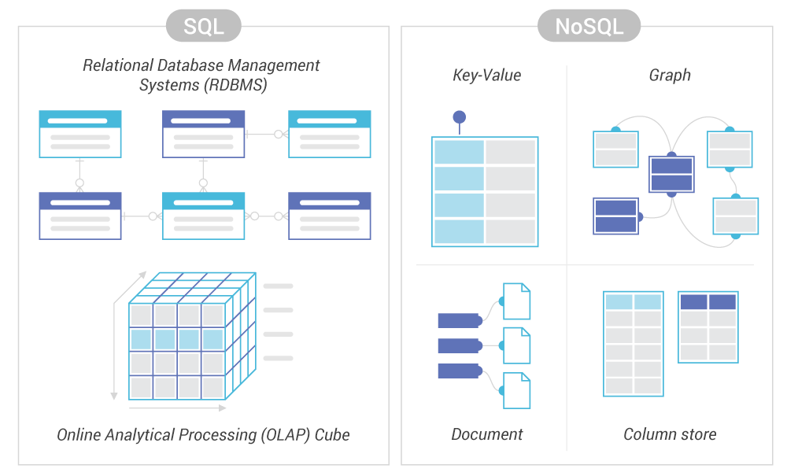

## Features of MongoDB

MongoDB is a leading NoSQL, document-oriented database that stores data in JSON-like BSON format. Key features include:

* Schema-less design: Documents can have varying structures.
* Scalability: Supports horizontal scaling via sharding.
* Flexibility: Stores rich data types including arrays and nested documents.
* Indexing: Supports secondary indexes to improve performance.
* Aggregation: Provides a powerful pipeline framework for data transformation and computation.
* Replication: Ensures high availability with replica sets.

**Key Features of MongoDB:**

* **Schema-Less Structure:** Collections in MongoDB do not require a predefined schema, allowing flexibility.
* **Document-Oriented Storage:** Data is stored as documents (key-value pairs) using BSON format.
* **High Availability:** MongoDB supports replica sets to ensure data redundancy and failover.
* **Horizontal Scalability:** Supports sharding, which allows data to be distributed across many machines.
* **Indexing:** Supports various types of indexing to improve query performance.
* **Aggregation Framework:** Powerful aggregation pipeline for data analysis.
* **Built-in Replication:** Ensures reliability and uptime.



